Babu Banarasi Das University

**NAME: Harshita Tiwari**

**ROLL NO: 1240258194(50) SEC: BCADS23**

**SUB: NO SQL (Mongodb)**

**Submitted to : Mr. Ankit Soni**

**-:NO SQL MONGODB PROJECT:-**

Q1. List the names and departments of students who have more than 85% attendance and are skilled in both "MongoDB" and "Python".

**ANS :**

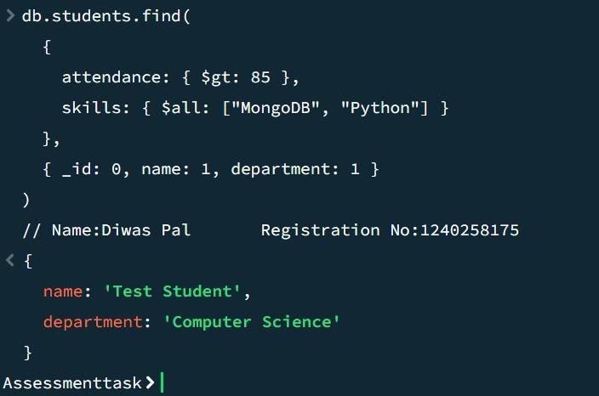

Q2. Show all faculty who are teaching more than 2 courses. Display their names and the total number of courses they teach

ANS:

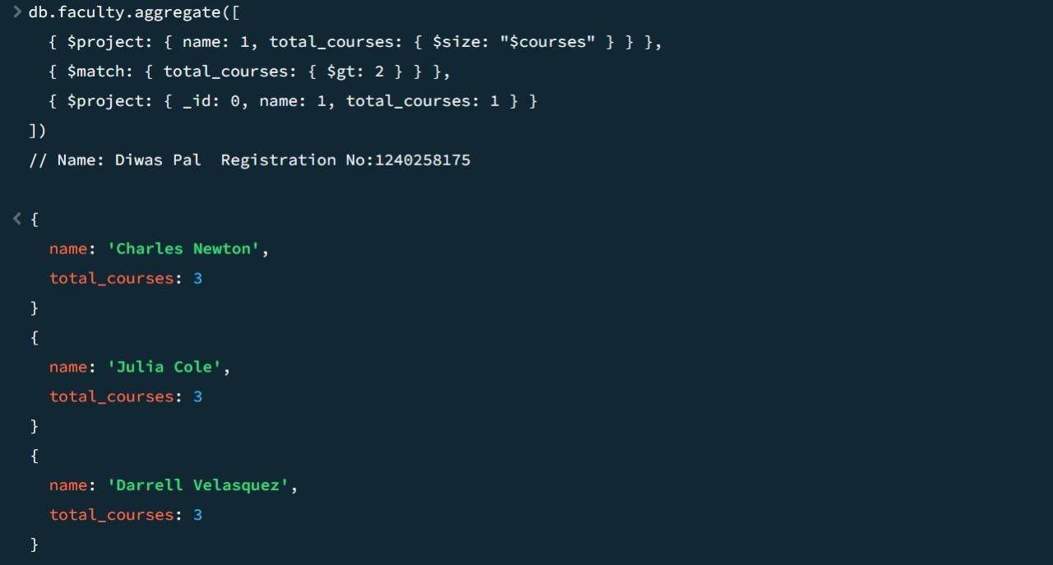

z

Q3. Write a query to show each student’s name along with the course titles they are enrolled in (use $lookup between enrollments, students, and courses).

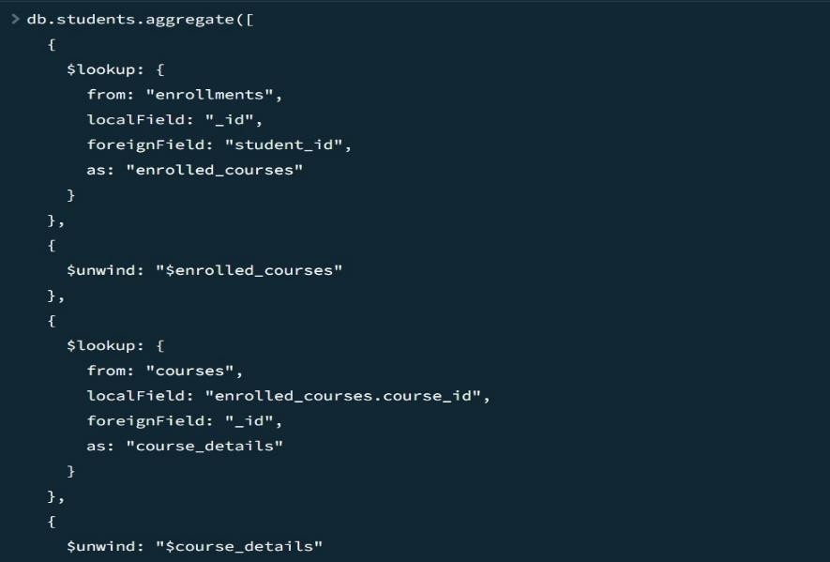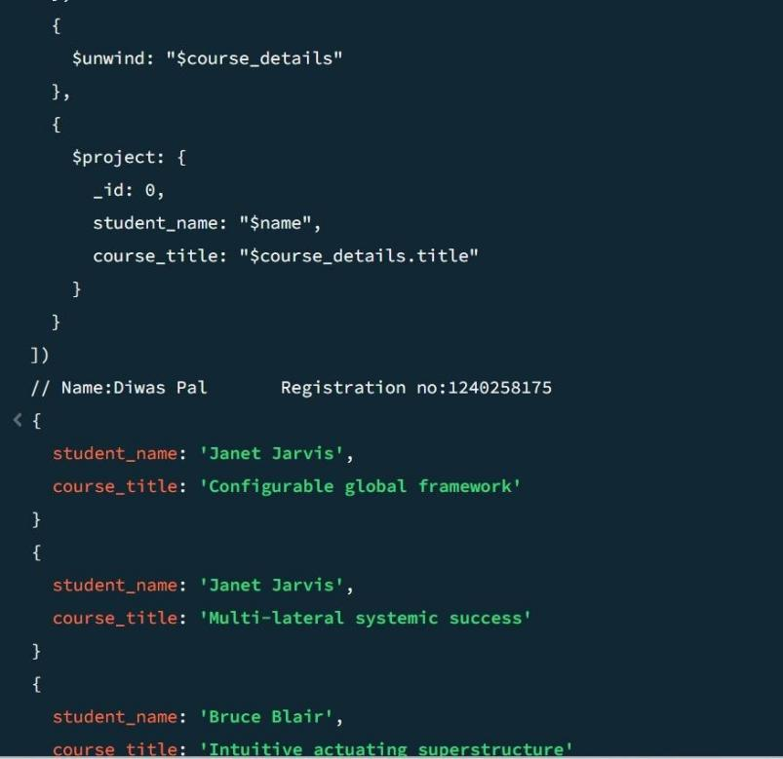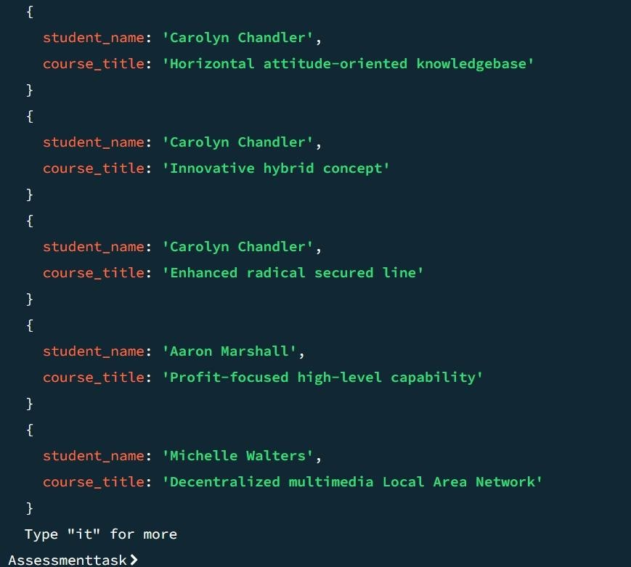

Q4. For each course, display the course title, number of students enrolled, and average marks (use $group).

ANS:

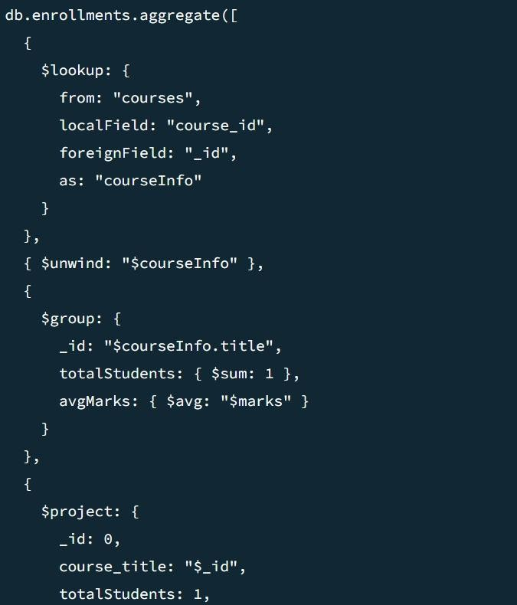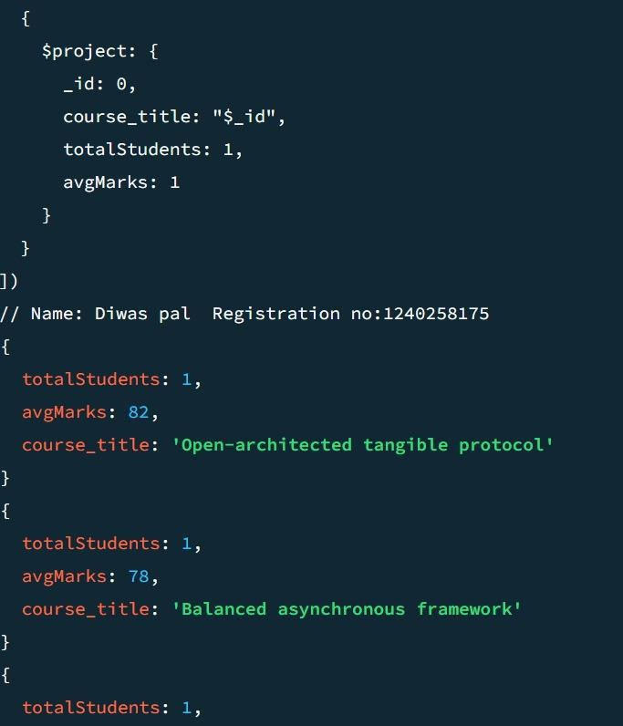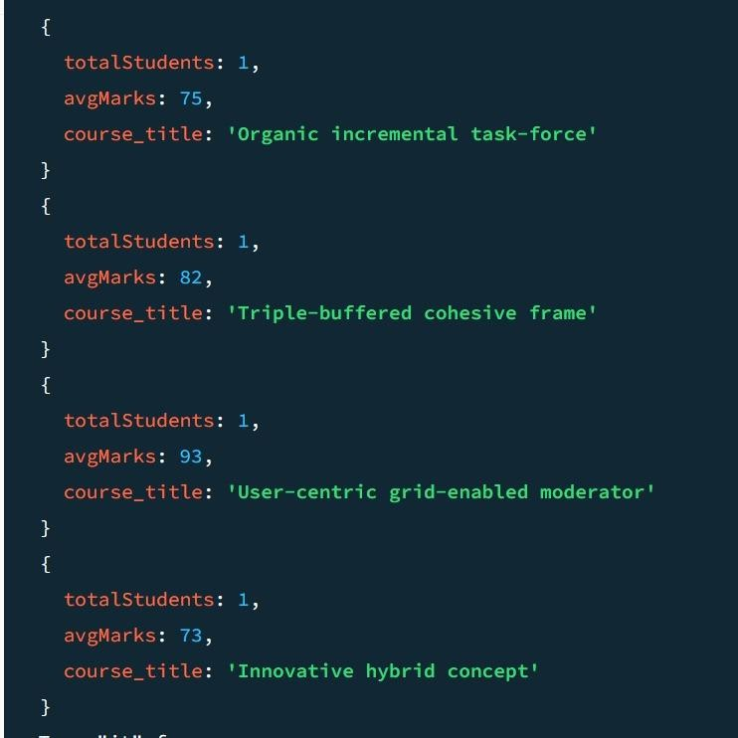

Q5. Find the top 3 students with the highest average marks across all enrolled courses.

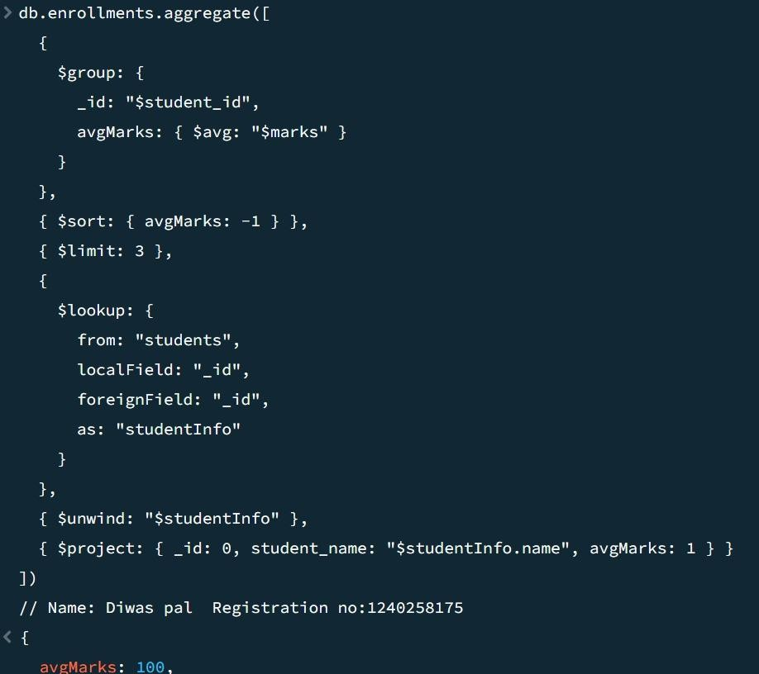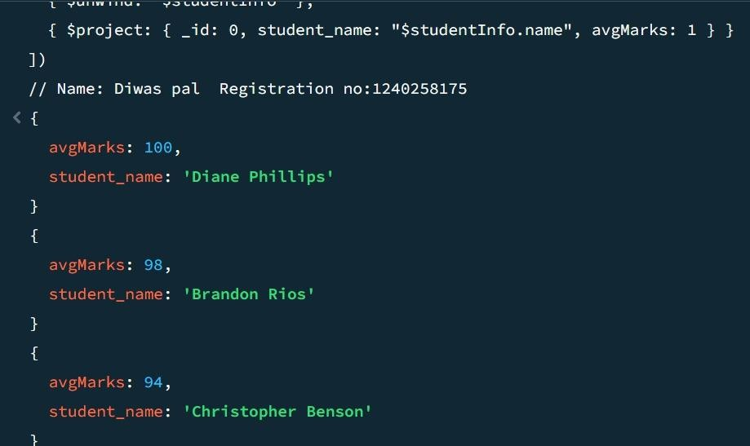

Q6. Count how many students are in each department. Display the department with the highest number of students

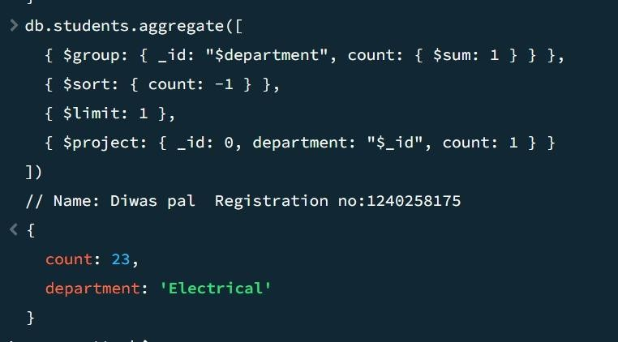

Q7. Update attendance to 100% for all students who won any "Hackathon".

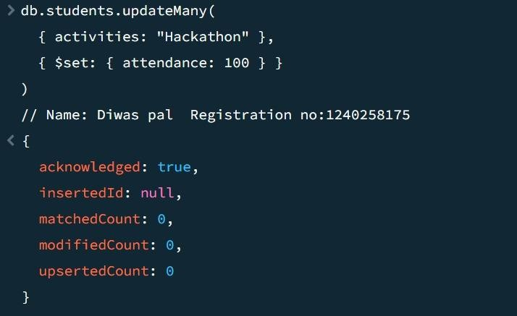

Q8. Delete all student activity records where the activity year is before 2022.

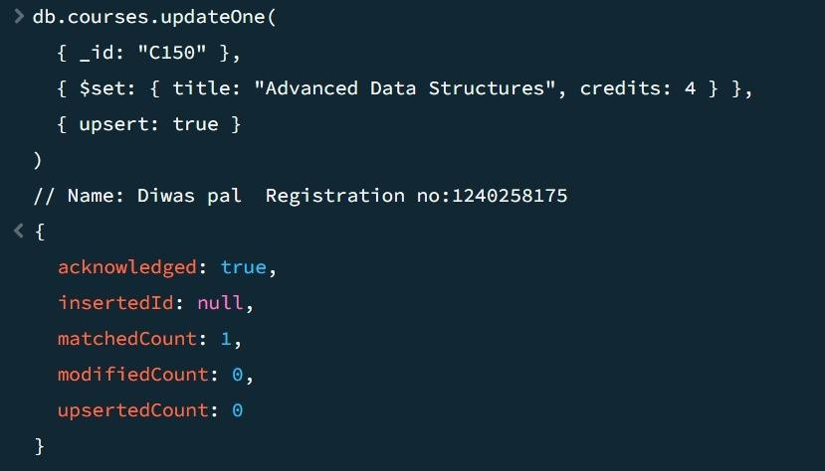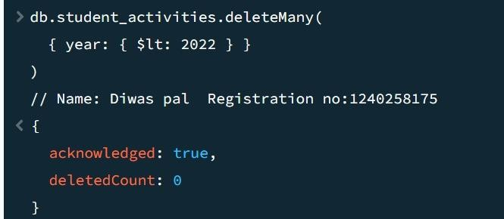

Q9. Upsert a course record for "Data Structures" with ID "C150" and credits 4—if it doesn’t exist, insert it; otherwise update its title to "Advanced Data Structures".

Q10. Find all students who have "Python" as a skill but not "C++".

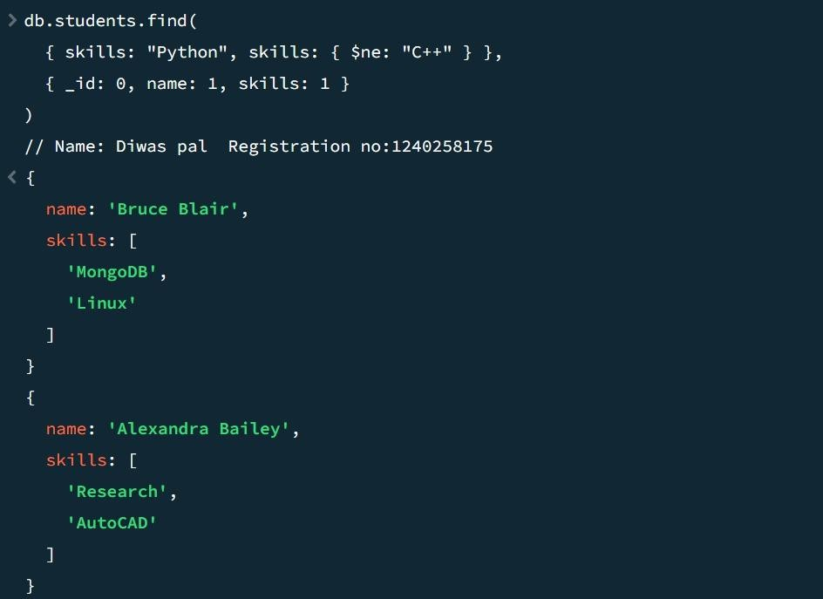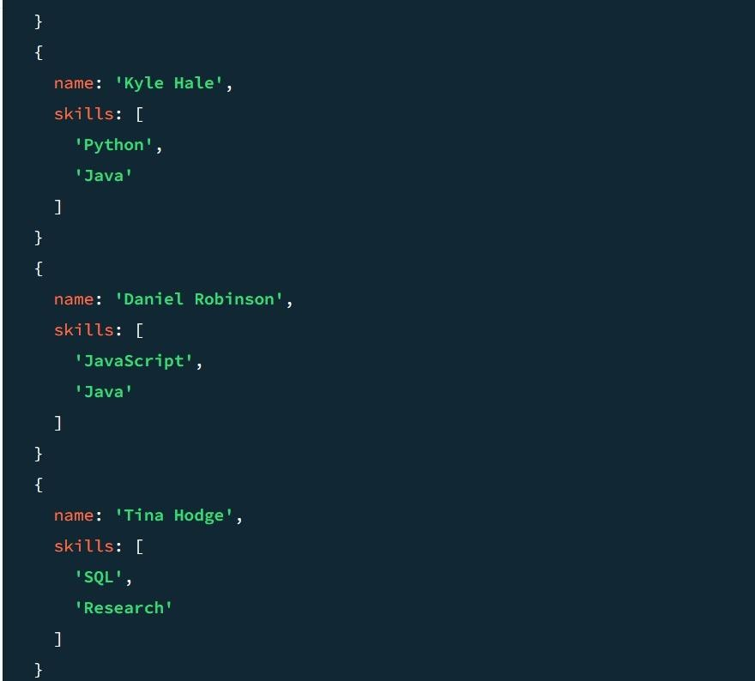

Q11. Return names of students who participated in "Seminar" and "Hackathon" both.

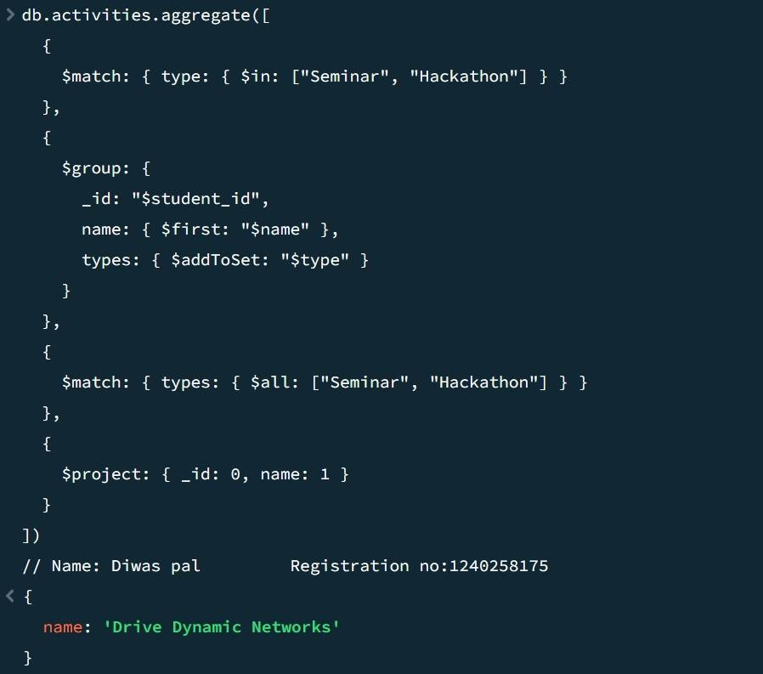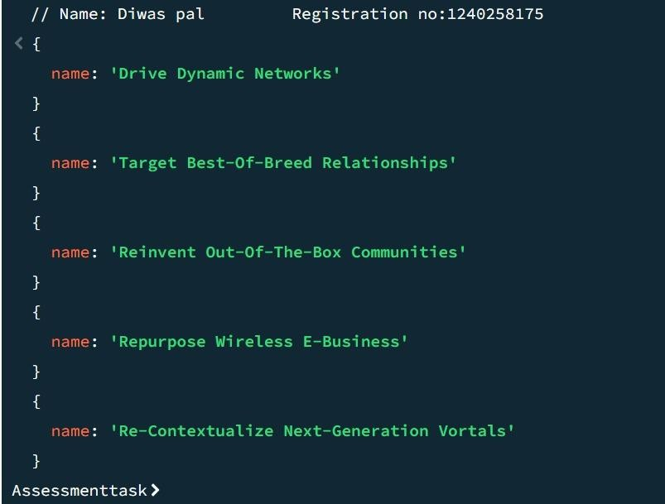

Q12. Find students who scored more than 80 in "Web Development" only if they belong to the "Computer Science" department.

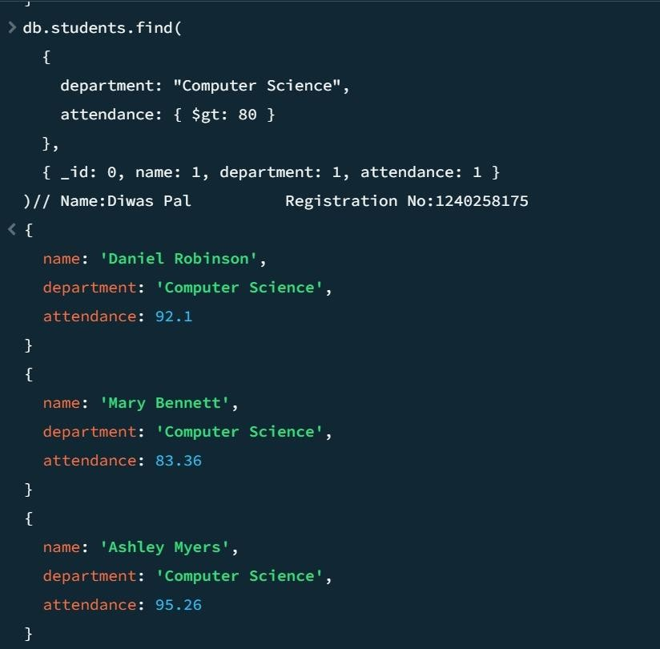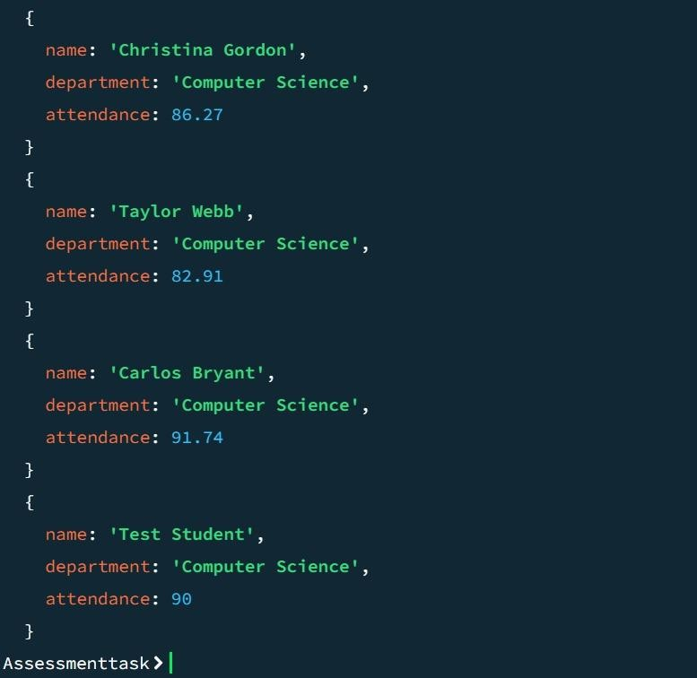

Q13. For each faculty member, list the names of all students enrolled in their courses along with average marks per student per faculty.

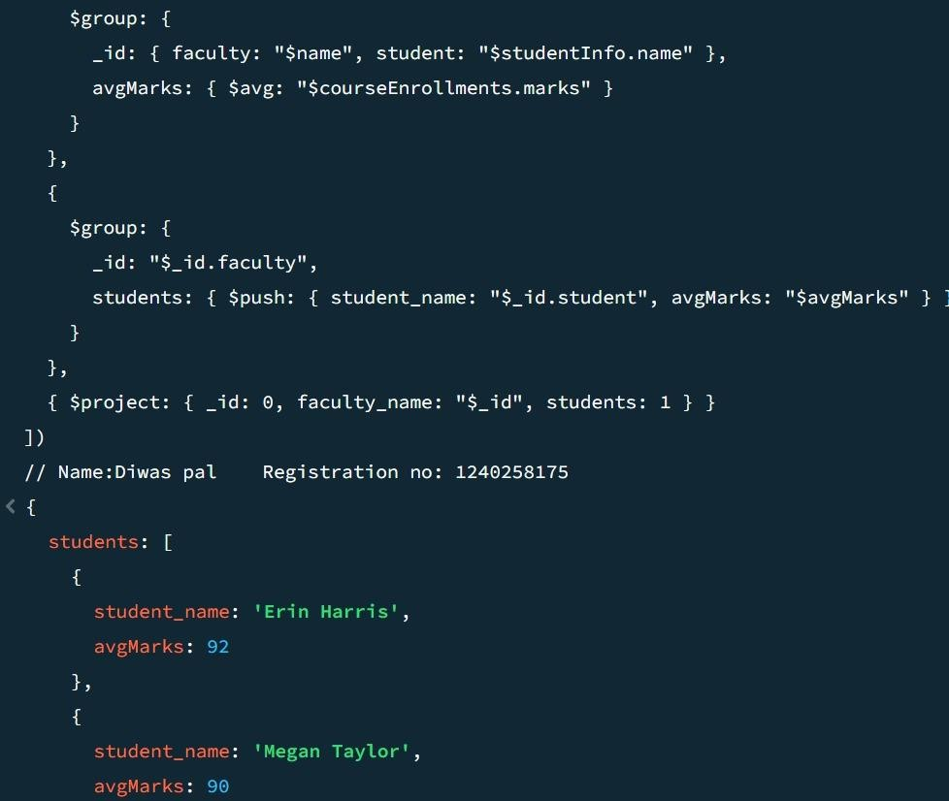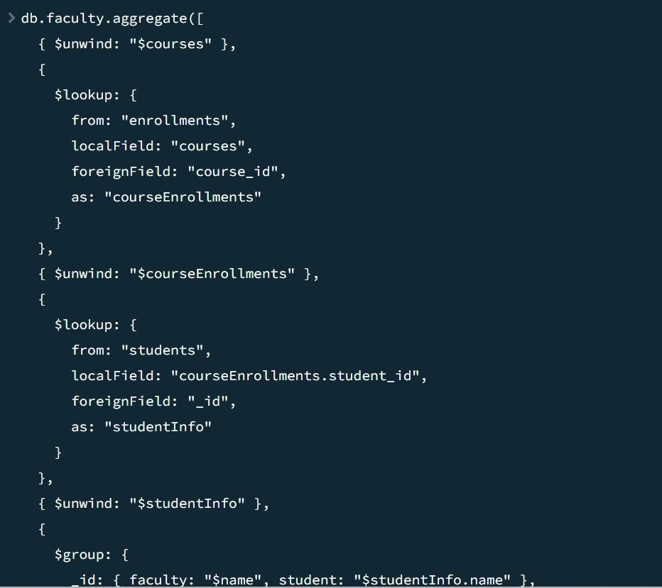

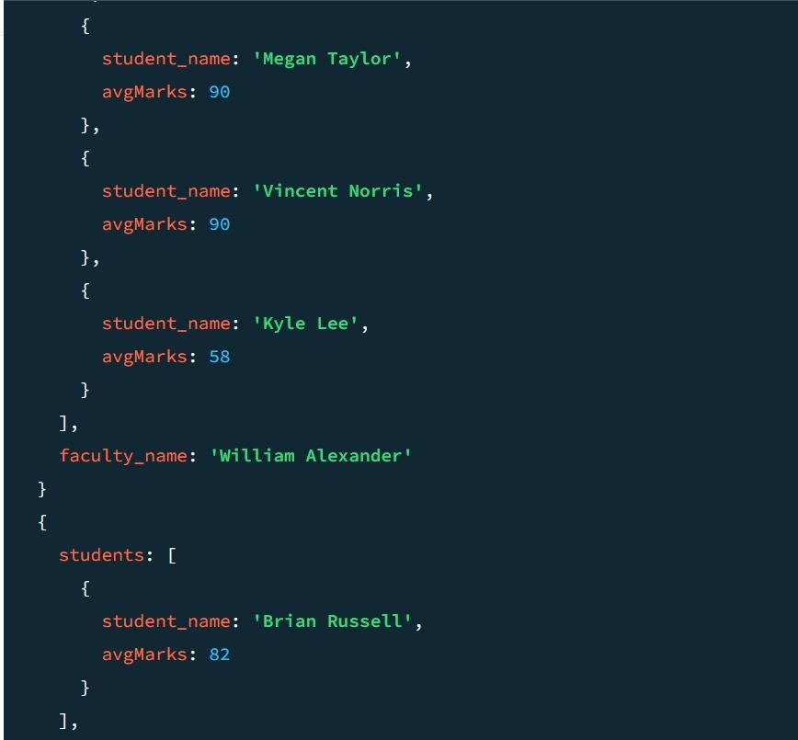

Q14. Show the most popular activity type (e.g., Hackathon, Seminar, etc.) by number of student participants.

